Functions :

Problem
Electricity Reading Aggregate Oracle

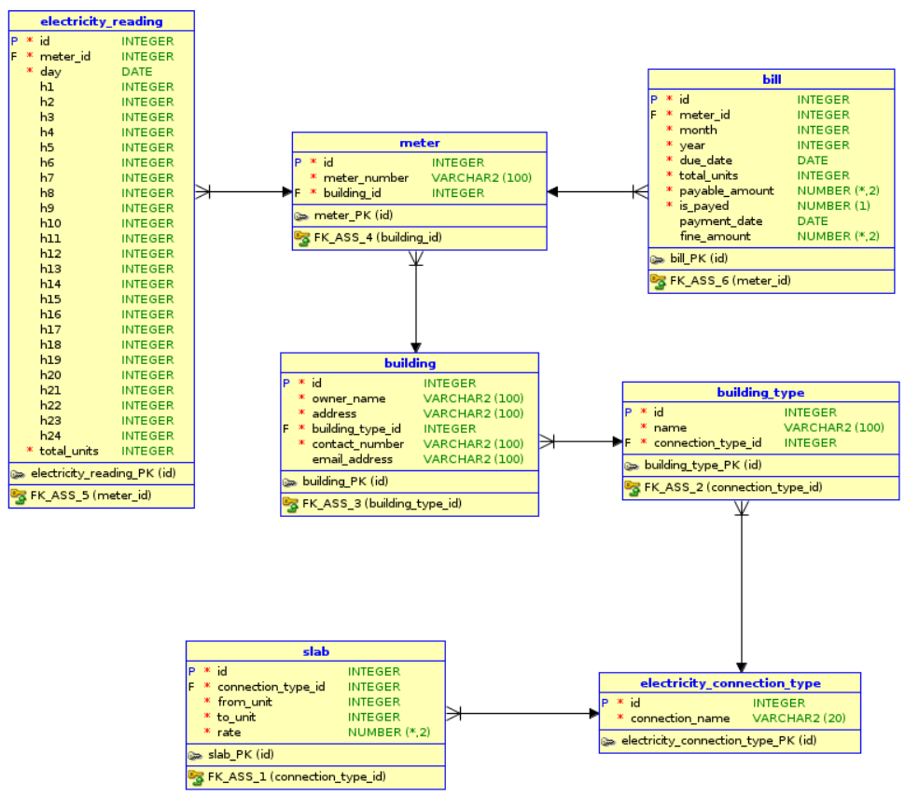

Q 1. Write a query to display the average unit of electricity consumption for all the users.Give an alias name to the average units as 'average_units_of_electricity'.
Ans:
SELECT avg(total_units) AS "average_units_of_electricity"
FROM electricity_reading;

Q 2. Write a query to display the sum of payable amount from bill.Give an alias name to the sum of payable amount as 'sum_payable_amount'.
Ans:
SELECT SUM(payable_amount) AS "sum_payable_amount" FROM bill;

Q 3. Write a query to display the owner name and the length of the owner's name of the buildings.Display the records in ascending order based on owner name. Give an alias as name_length to the length of the owner names.
Use the inbuilt function length().
Ans :
SELECT owner_name, length(owner_name) AS "name_length"
FROM building ORDER BY owner_name;

Q 4. Write a query to display all the owner_name and concatenated contact_number and email with a hyphen(-) separated . Display the records in descending order based on owner_name .Give an alias name as 'contact_details'.
Ans:
SELECT owner_name, concat(concat(contact_number, '-'),email_address) AS "contact_details"
FROM building ORDER BY owner_name DESC;

Q 5. Write a query to display the first 3 characters of each meter number.Give an alias name for the meter number as 'meter_code'.Display the records sorted by meter_code in descending order.
Use the inbuilt function substr().
Ans :
SELECT SUBSTR(meter_number,1,3) AS "meter_code"
FROM meter ORDER BY meter_number DESC;

Additional :

Problem
Refere the schema and solve the following Query requirements

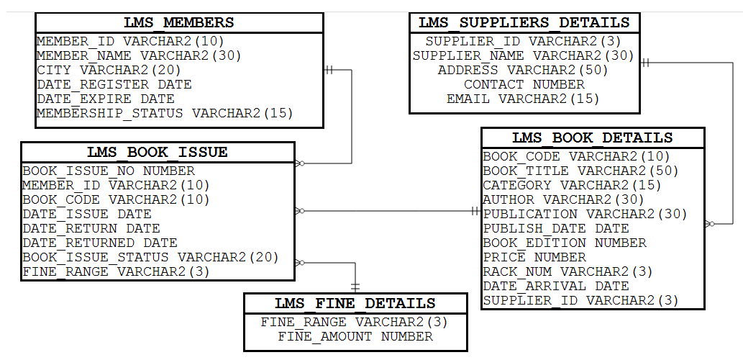

Q 1. Write a query to display the supplier_id, supplier_name and contactdetails of all the suppliers. The contact details can be either phone number or email or address with alias name “CONTACTDETAILS”. If phone number is null then display email, even if email also null then display the address of the supplier. Display the records sorted in ascending order based on supplier_id.
Hint:
Use Coalesce function.
Ans :
SELECT Supplier_id, supplier_name, Coalesce(To_Char(contact),email,address) AS "CONTACTDETAILS"
FROM LMS_SUPPLIERS_DETAILS ORDER BY supplier_id;

Q 2. Write a query to display the supplier_id, supplier_name and phone number availability status of all the suppliers.
If phone number is null then display ‘No’ else display ‘Yes’ with alias name “PHONENUMAVAILABLE”.
Display the records sorted in ascending order based on supplier_id.
Hint:
Use NVL2.
Ans :
SELECT supplier_id, supplier_name,case when contact is NULL then 'NO' when contact IS NOT NULL then 'YES'end AS "PHONENUMAVAILABLE"
FROM LMS_SUPPLIERS_DETAILS ORDER BY supplier_id;

Additional:

Problem
Alumni Management System - DML - Basic Select Queries II
Refer the ER Diagram for Alumni Management System.
Write the following select queries.

Q 1. Write a query to display the number of queries raised/answered between 1 a.m and 5 a.m (both inclusive). Give an alias as number_of_queries.
Ans:
SELECT count(*) AS "number_of_queries" FROM query
WHERE extract(hour FROM query_date) BETWEEN 01 AND 05;

Q 2. Write a query to display the name of the month and the number of events scheduled in each month in the year 2013. Give an alias as Month and number_of_events. Display the records sorted in ascending order based on Month.
The name of the month must be displayed as January, February …
Ans:
SELECT TO_CHAR(event_date,'month') AS month, count(*) number_of_events FROM event
WHERE extract(year FROM event_date)=2013
GROUP BY TO_CHAR(event_date, 'month')
ORDER BY month;

Assess:

Problem
Metro_Station(String)-Oracle-iLearn
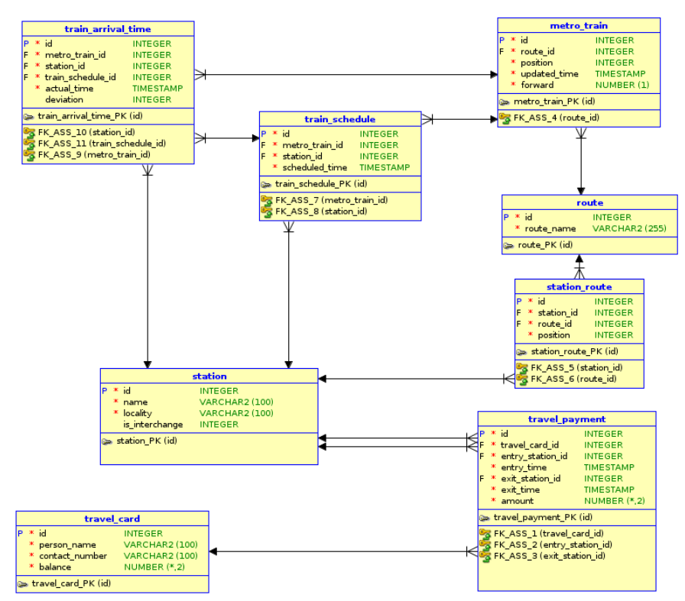
Q 1. Write a query to display the concatenated person name ,contact number and balance details seperated by hyphen(-).Give an alias name as person_details.Display the records in ascending order based on person name
Ans:
SELECT concat(concat(concat(concat(person_name, '-'),contact_number),'-'),balance) AS "person_details"
FROM travel_card ORDER BY person_name;

Q 2. Write a query to display the route_name in a 20 character length field by left padding with '*'. Give an alias name for the route_name as 'updated_route_name'. Display the records sorted in ascending order based on route_name.
Ans :
SELECT LPAD(route_name,20,'*') AS "updated_route_name" FROM route ORDER BY route_name;

